***What is wazuh?***

**Wazuh** is a **free, open-source security platform** that provides threat detection, monitoring, and response capabilities for endpoints and cloud environments. It helps organizations with security information and event management (**SIEM**), log data analysis, intrusion detection, compliance, and more.

***Wazuh installation requirement!***

Wazuh requires a Linux-based OS such as Ubuntu, CentOS, Debian, or RHEL. For small or test environments using a single-node setup, the minimum is a 2-core CPU, 4 GB RAM, and 20 GB disk, though 4+ cores, 8 GB RAM, and SSD storage are recommended. In production, where Wazuh Manager, Elasticsearch, and Overview run on separate servers, higher specs are needed—typically 4+ cores and 8–16 GB RAM per component. Key software dependencies include Python 3, GCC, Make, and OpenSSL. Network ports 1514 (UDP/TCP) and 1515 (TCP) must be open for agent communication. Proper planning ensures efficient performance and scalability.

So first I open my wazuh overview in my browser then I open my vm for inputting the wazuh-agent

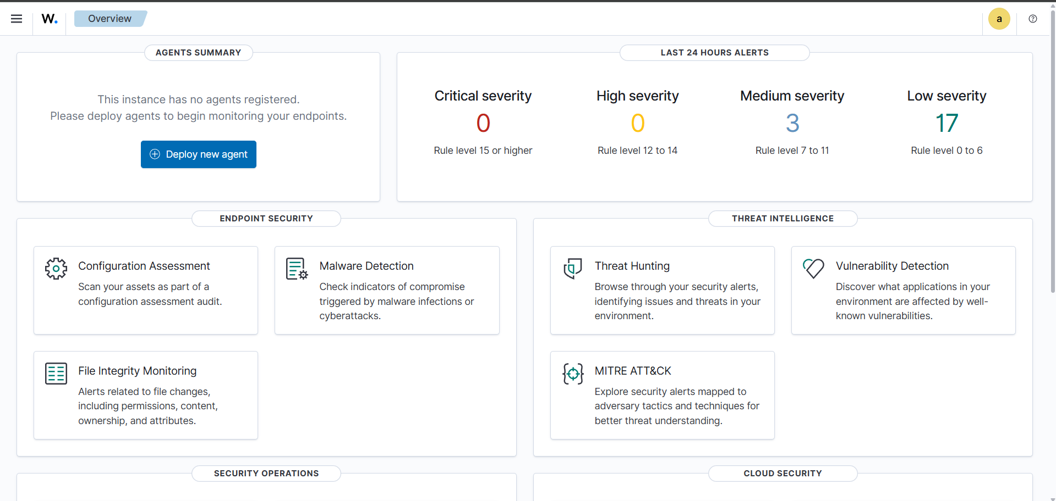

So here my wazuh overview now I teach you how can you upload wazuh-agent in your vm’s

After this click on the “*deploy new agent”* after that you get a new interface

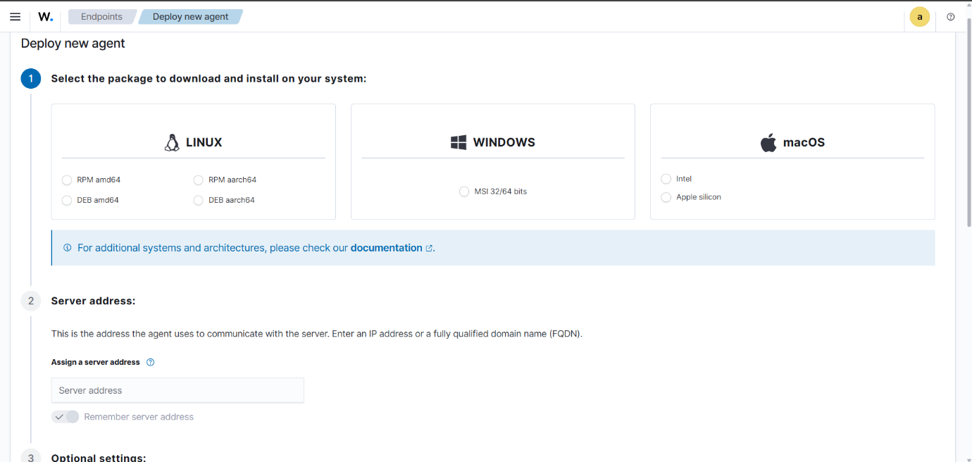

Like this after this find the system version of our vm

So first open your vm machine and become a root user

After that get the system info of our vm



As you see I get my system info so now I upload details on wazuh overview

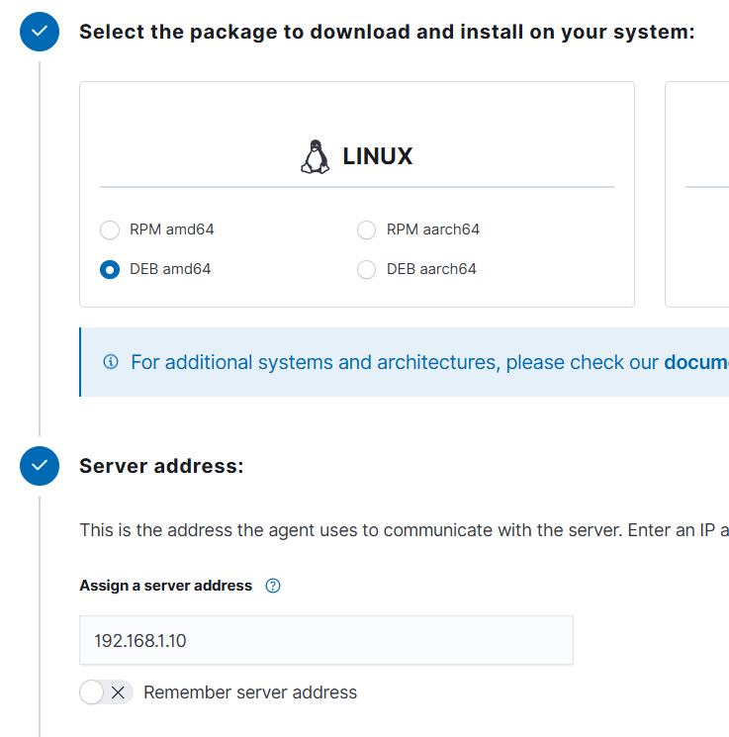

After checking my system information, the third option is perfect for my setup

After this I add server address

In server address I want to add wazuh ip in server address just like my wazuh ip address is “192.168.1.10”

After this I assign agent name ( my agent name is ‘deathnote’) you can also add name anything as you want

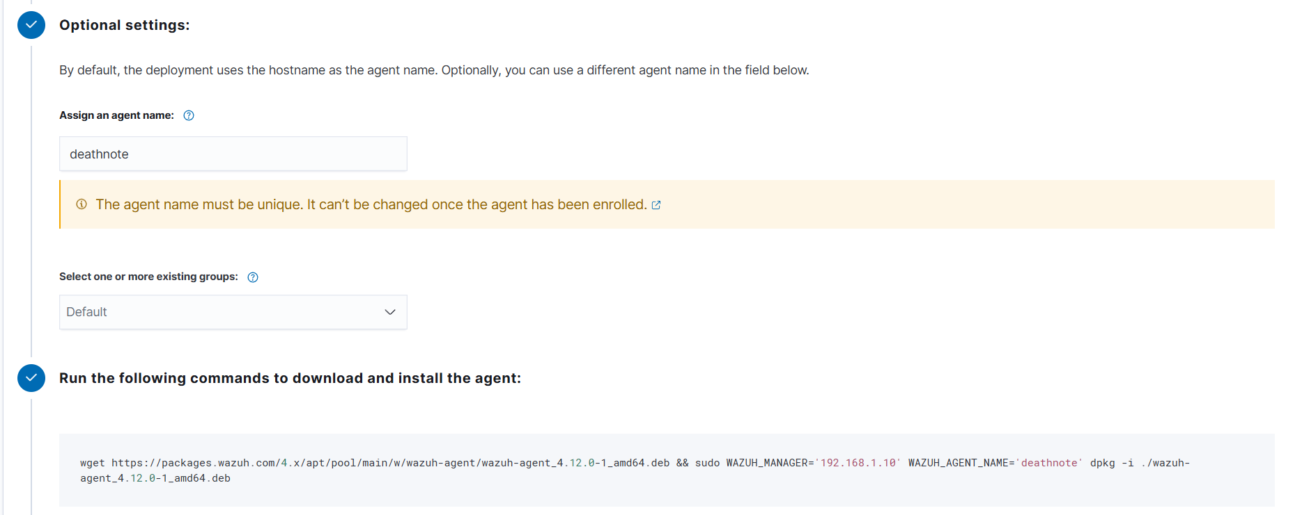

In fourth option I want to upload that command on my vm

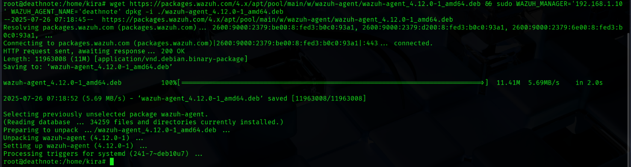

Like this after this I start my wazuh-agent on my vm

For starting the wazuh-agent that command also you get in wazuh overview

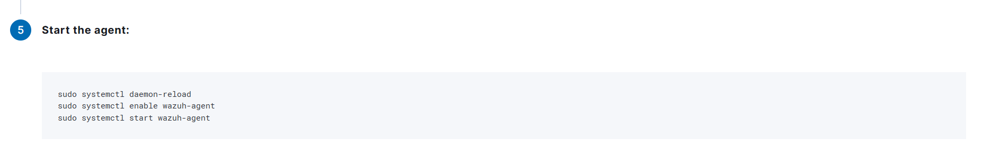

This are the command you already get in our wazuh overview so copy this command and upload on that vm



Like this and done

Now you successfully upload wazuh-agent on your vm machine

After this go to your wazuh overview again then you get something different

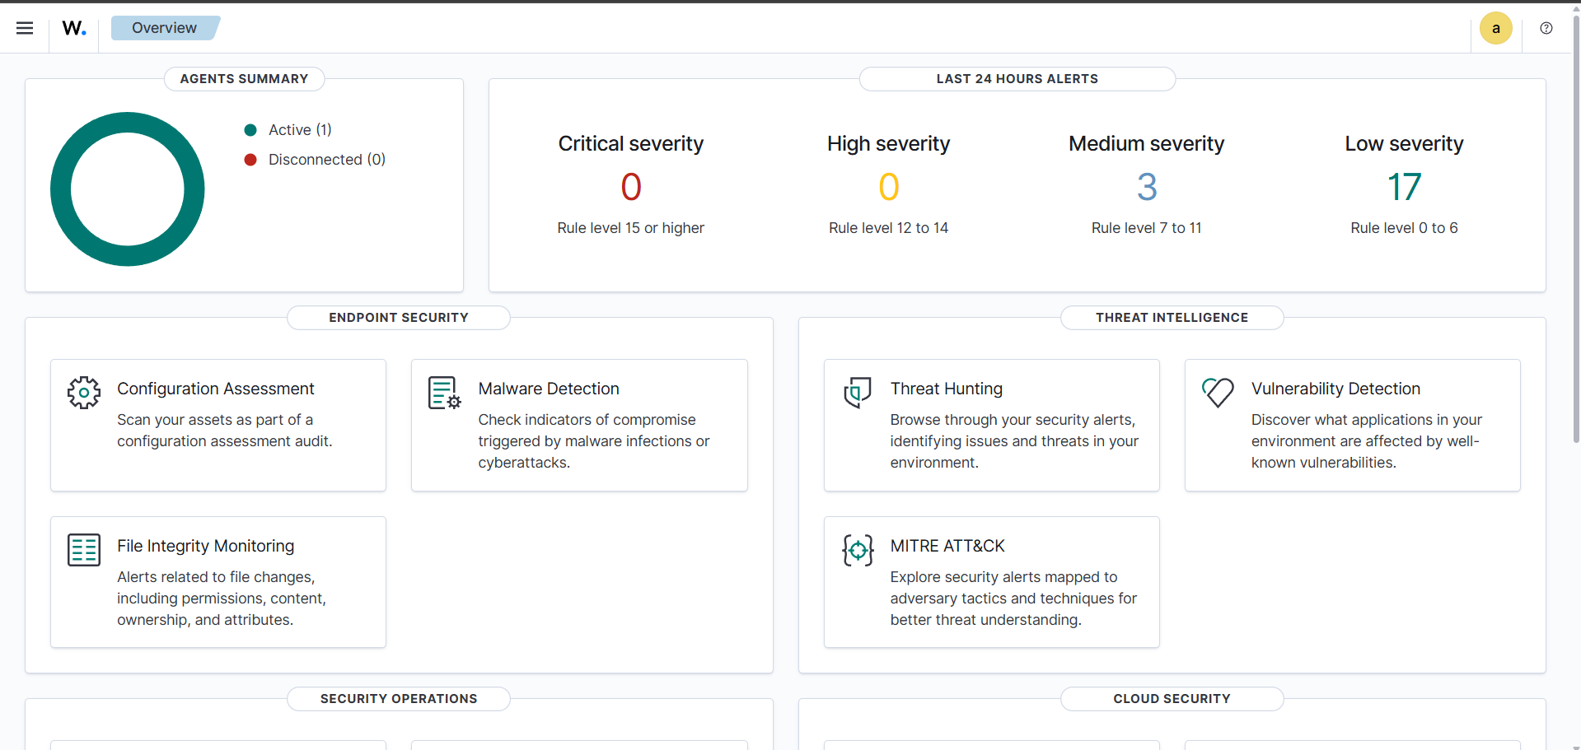

Now you get agents summary on your overview for more information click on that ‘active’ after that you get more information for your agent

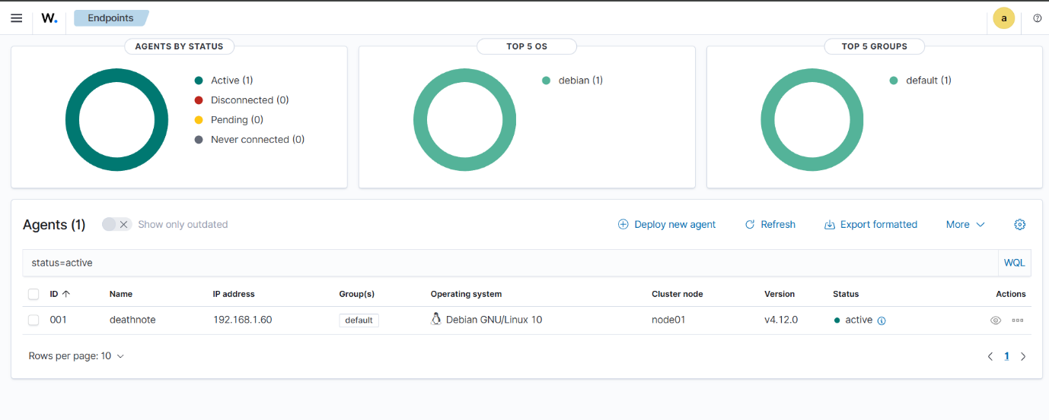

Like this and done

If you want to add more agent then click on that deploy new agent below top 5 OS side

And like this steps you can add more add agent on your vm/windows/macos

For windows upload command on powershell (first open powershell on admin)

After that upload last point and done